Here is a collection of some Poi Waiata to add to your kete of waiata. There are old favourites and some are new. There are also a couple of Poi Waka and some exciting Spin Poi.
Matua Whaitiri Pourewa is a primary school kapahaka tutor from Te Awakairangi, Lower Hutt. He has recorded some very clear instructions on making poi and poi actions. Tamariki and whānau find him easy to follow, he has such a friendly commanding tone to his kapa haka voice. There are more rauemi on his video, including karakia and haka.
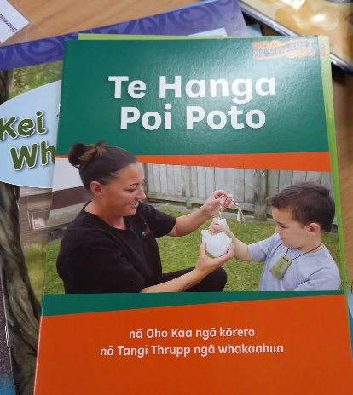
An easy way to learn a new action waiata is to start with one or two waiata, then go through the video in your own time to learn the actions and become familiar with the words and tune.
You could make a playlist of favourite waiata to make transitions between waiata easier.
Playing poi waiata in centres is fun and engaging, tamariki learn from watching you as you swing the poi in time to the music. Repetition is key to learning. Plan to have a regular waiata time, some centres do this after karakia in the morning, before kai time, or at the end of session while the centre is being tidied up. Playing waiata in the background of a general play session can inspire creativity, and is an easy way to learn the words and rhythm. You can also ‘free style’some poi waiata too!
Karawhiua tō poi!
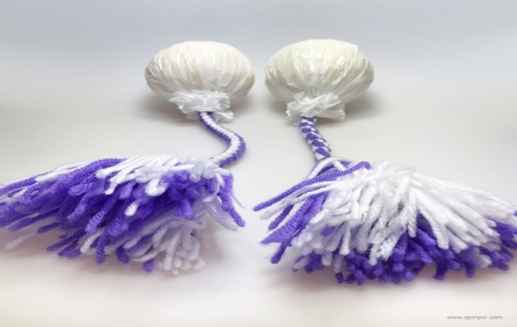
Karakia  Mā ngā Atua Māori,  e tiakina, e arohaina i ahau,  mā rere tōtika a te mahi pai.  Mā te rere a te poi, ka tau ai te mauri ki roto i a tātou. Haumi E, Hui E, Taiki E | Invocation  May the Māori Gods  protect and love us,  and guide us in doing good work. Let the flow of the poi give us energy and life. Join, Gather, Unite.
SpinPoi

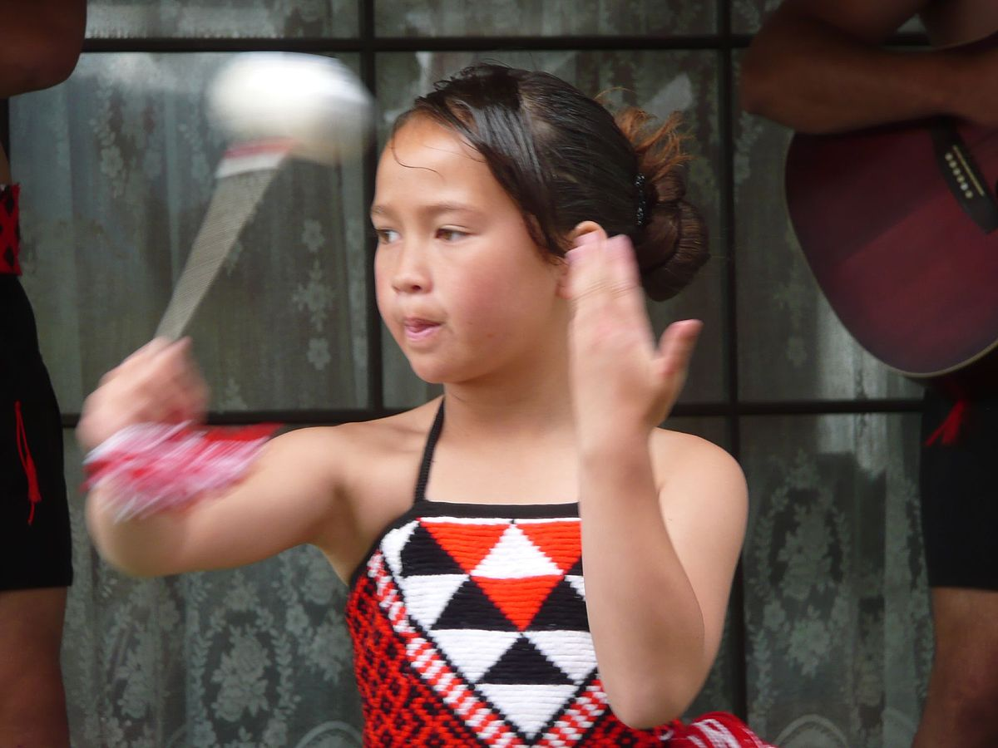
This Photo by Unknown Author is licensed under CC BY-SA

Rere Atu Rere Mai
https://youtu.be/tj0g370zrfQ by Children love to sing – sung in Māori and English

Rere atu, rere mai  Taku poi rere mai  Rere runga, rere raro  Rere tika e, rere tika e | Fly away, fly back  My poi fly to me  Fly up, fly down  Fly straight along  Fly true, fly true

E Rere Taku Poi https://youtu.be/mg6gdVGDKF4 Matua Whaitiri (16.54min) https://youtu.be/p5XoYtkySNA actions by Loopy Tunes
E rere taku poi, E rere taku poi, Ki runga, ki runga  E rere taku poi, E rere taku poi, Ki raro, ki raro  E rere runga, E rere raro, E rere roto, E rere waho  E rere taku poi, E rere taku poi, Ki runga, ki runga | My poi is flying  My poi is flying  Up high, up high  My poi is flying  My poi is flying  Down low, down low  Flying high  Flying low  Flying in  Flying out  My poi is flying  My poi is flying  Up high, up high

Pūrerehua Rere Runga Hau By Hirini Melbourne https://youtu.be/KV4IToyeHLU Matua Whaitiri (13.55min) https://youtu.be/mg6gdVGDKF4 Matua Whaitiri (20.14 min)
Purerehua  rere runga hau  Papaki parirau  Rere runga hau  Ka piki, ka piki  Runga rawa e  Papaki parirau  rere runga hau | Butterfly  carried on the wind.  Fluttering its wings  on the wind  Up and up  Way up high  Fluttering its wings  on the wind

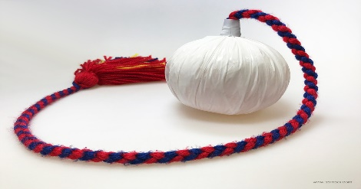

Poipoi E, Poipoi E By Matua Whaitiri Poutawa, https://youtu.be/kFpElj4e3WA (22 min) goes through actions of Poipoi e
Poipoi e, poipoi e  Rere atu rere atu  Poipoi e (x 2)  Ti patu patua  Ti patu mai  Rere atu rere atu  Ti patu mai  Aue aue hei hei hā (x3)  Aue aue poipoi mai | Swing, swinging  Fly away. Fly away  Swinging  Hit hitting  Hit towards me  Fly away fly away  Hitting towards me  Oh . . . . . . .  Oh . . . . . . . Swinging to me

He Poi Whatiwhati E https://youtu.be/mg6gdVGDKF4 Matua Whaitiri (25.27 min)

He poi whatiwhati e  He poi korikoria  He poi kanikani  Menemene pukana e  He poi kanikani  Menemene pukana e | A poi is swinging from side to side  A poi is moving  A poi is dancing  Smiling and staring wildly  A dancing poi  Smiling and staring widly

Whiti te Marama i te Pō
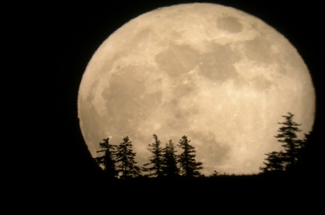

By Hirini Melbourne https://youtu.be/HpdY2X85srQ sung by Hirini Melbourne https://youtu.be/mg6gdVGDKF4 Matua Whaitiri (26.21 min)
Whiti te marama i te pō  Tīaho iho mai koe  Hei karu mō te mata o te pō (x2)  Tō ana te rā ki te moe e  Tīaho iho mai koe  Hei karu mō te mata o te pō (x2)  Ki te kore koe,  te karu o te pō  Pōuri ana taku ara e (x2)  Hoki ana ahau, ki te moe e  Tiaho iho mai koe  Hei karu mō te mata o te pō (x2)  Whitiwhiti te marama i te pō  Tīaho iho mai koe  Hei karu mō te mata o te pō (x2)  Whitiwhiti ana e  Te marama o te pō (x2) | Shining moon in the night, you shine your light  You are the light of the night  The day is yours to sleep  You shine your light  You are the light of the night  If you are not shining  The night sky is dark  My path is saddened  Even when I am sleeping,  You shine your light you are the light of the night  The moon shines at night  You shine your light  For you are the light of the night  Shinning  The moon of the night

Taku Poi By Matua Whaitiri https://youtu.be/B3n0BkL44Ck

Ki runga, ki raro, toru whā  Ki runga, ki raro, ki tai taku poi  Tū ana, tū atu, tū mai  Taku poi  He manu e rere mīharo  Taku poi  E rere atu ki te ao  E rere atu ki te ao  E rere atu ki te ao  (repeat)  Ka tahi ka rua āue hī! | Upwards, downwards, 3, 4  Upwards, downwards, towards the sea, my poi  Standing, away, to me  My poi  An amazing flying bird  My poi  Flying away to the world  One, two !!

E Rere Taku Poi https://youtu.be/LCpetlca-hQ
E rere taku poi  Mauria atu rā  Ngā riri o te moana  E papaki mai nei  Ko taku aroha  Me kawe ki te tau  Kī atu kia hoki mai | Fly my poi  Carry over  The angry seas  And crashing tides  My enduring love  To my beloved  Tell him to return to me

Hoea Rā Te Waka Nei By Pariare Tomoana NZ Folk Song * Hoea Ra Te Waka Nei This waiata was sung to accompany the ‘canoe poi” using two short poi, a very popular eye-catching item performed by girls during the era of Native Schools (later known as Māori Schools). The girls sat in a line, twirling the poi in time with the singing, using different actions that resembled the movement of paddle
Hoea rā te waka nei  Hoea hoea ki te pai  Mā te poi e karawhiu  Kia rere tika ai (x2)  Haere mai, e hine mā  Me ngā taonga o te wā  He reo karanga i te ao katoa  “Haeremai ki au” (x2) | Paddle this canoe  Paddle paddle to prosperity  The poi will urge it forward  So that it will sail straight  Welcome, maidens  With the treasures of time  A voice calls all the world  “Come to me”

Poi Waka https://youtu.be/0PR0Xu9OJfk (.58min)
Tōia mai ngā waka e te iwi e  Hoea hoea rā  Aotea, Tainui, Kurahaupo  Hoea hoea rā  Töia mai nga waka e te iwi e  Hoea hoea rā  Mataatua, Te Arawa, Täkitimu  Tokomaru hoea hoea rä  Hoea rā te waka nei.  Hoea, hoea ki te pae.  Mā te poi e karawhiu  Kia rere tika ai.  Haere mai e hine mā  Me ngā taonga o te wa  He reo karanga i katoa  Haere mai ki au | Haul the canoes everybody  Sail, sail there  Aotea, Tainui, Kurahaupo  Sail, sail there  Haul the canoes everybody  Sail, sail there  Mataatua, Te Arawa, Takitimu  Tokomaru paddle, paddle back  Sail the canoe.  Sail, sail to the horizon.  May the swing of the poi  indicate the right direction.  Come girls  bring the gifts of the time  calling to all  Come to me.

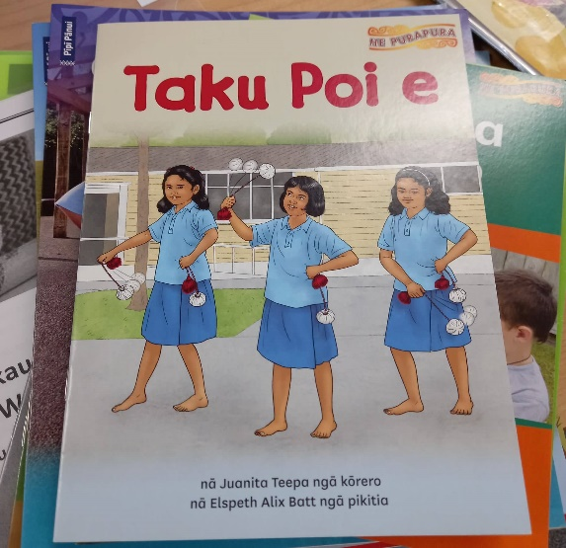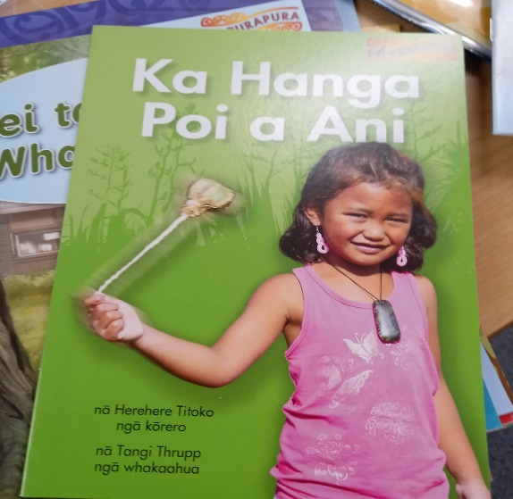

Pukapuka are from Learning Media, Down the back of the chair

