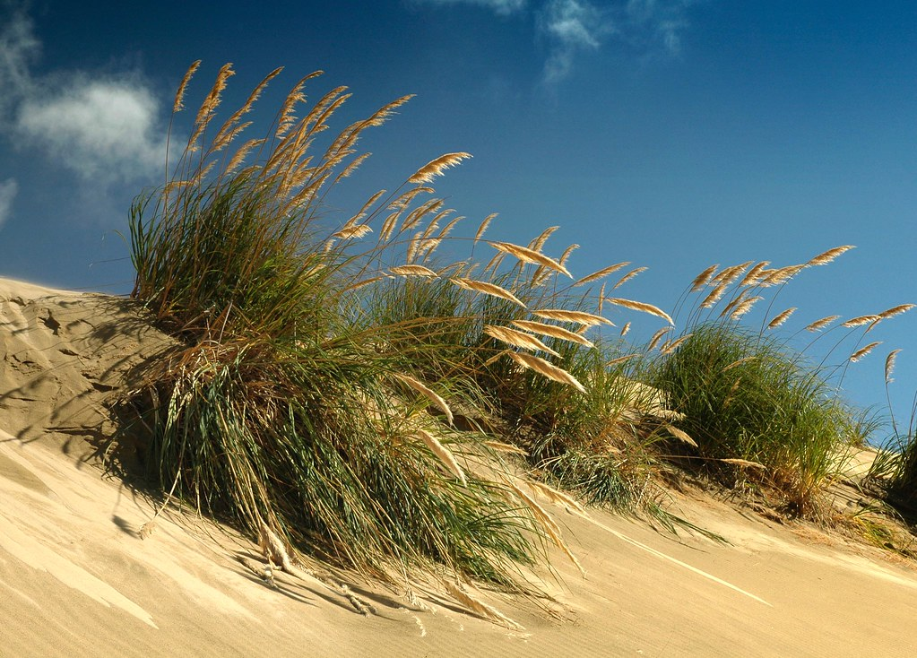

**Ki te kotahi te kākaho, ka whati. Ki te kāpuia, e kore e whati.**

**If there is but one toetoe stem it will break, but if they are together in a bundle they will never break.**

**(Nā Kīngi Tāwhiao tēnei tongi. This saying is by King Tāwhiao).**