Pūrākau – Tāwhirimātea
Feb 2023
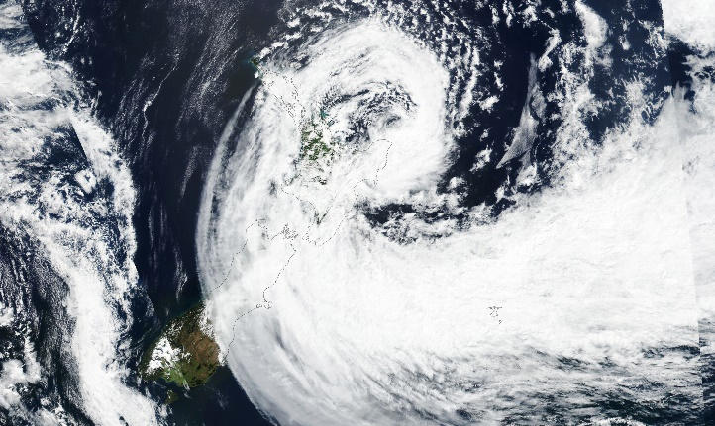
Tāwhirimātea (Atua of the wind and storms) was on a rampage, unleashing his fury on his brothers for causing the separation of Ranginui (Atua Father of the Sky) and Paptūānuku (Atua Mother of the Earth). He sent his tamariki - wild turbulent winds in all directions (marangai and hautonga), dense dark thunderstorm clouds (aonui, aopōuri and aopakarea) released heavy, long rain (uanui and uaroa). He wrought havoc on Tāne Mahuta (Atua of the forest) battering forests to create devastation on Papatūānuku. Tāwhiri stirred up Tangaroa (Atua of the sea) to send huge waves crashing against the shore, and lashed out at Rongomātane (Atua of the cultivated kai) and Haumietiketike (Atua of uncultivated kai) demolishing their crops. Tāwhirimātea bombarded Tūmatauenga (Atua of war and mankind), but Tū battled against Tāwhiri. Eventually, the tears from Ranginui stopped to allow Tama-nui-te-rā (Rā, the sun) to dry up some of the whenua revealing catastrophy upon Papatūānuku, it will take a long time for Papa to recover and replenish that which was lost, it will take longer for Tū to revive restore the tangata whenua. Not to be left out, Rūaumoko (Atua of earthquakes) rumbles within the depths of Papatūānuku.
Cyclone Gabrielle Lashes New Zealand (nasa.gov)
Here is some more information about the Ātua Māori and how it relates to the weather and the environment.
Origins of the weather – Te Ara Encyclopedia of New Zealand

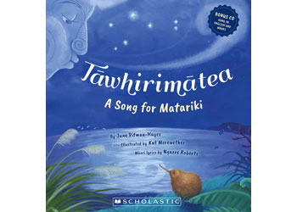
Pukapuka
Tāwhirimātea, A Song for Matariki by Jane Pitman Hayes, illustrated by Kat Merewether, Māori lyrics by Ngaere Roberts.
Sing along to celebrate earth, sky, seasons and whānau.

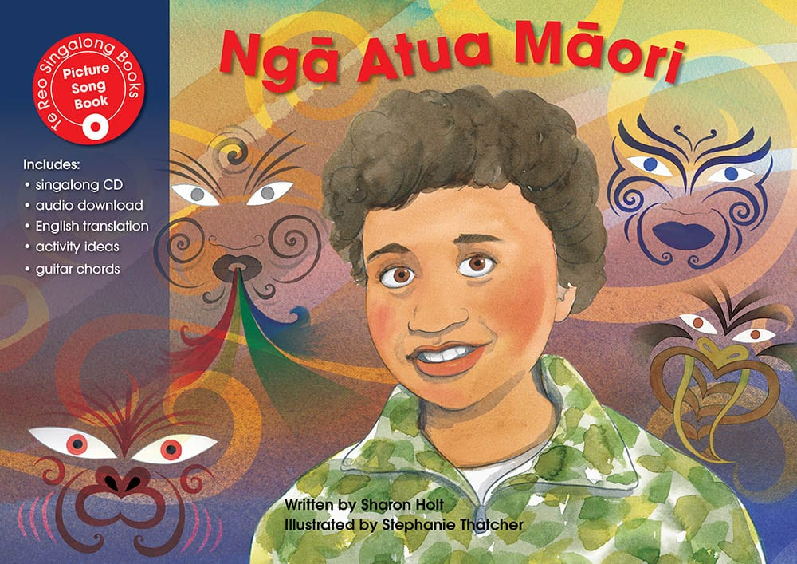
Ngā Atua Māori (The Māori Gods) - Te Reo Singalong
This book connects the Atua Māori with tamariki as kaitiaki, guardians of the environment.
Written by Sharon Holt,
Illustrated by Stephanie Thatcher

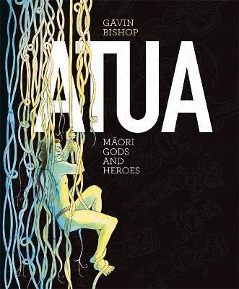
An award winning, stunningly illustrated this big book comes highly recommended. Easy to follow text introducing all the Atua Māori and heroes as these pages take you from the creation to migration.
Written and illustrated by Gavin Bishop.

